Understanding land tenure and property rights in your city
The law of unintended consequences shows that unless one can anticipate the outcomes of a policy, they will be different from what is intended. This applies very much to policies on land tenure and property rights, so it is vital that before preparing a policy to improve tenure security, a sound understanding of the full range of existing tenure categories and the associated rights that apply to them are understood.
In practice, this is difficult as in any city there are a range of both formal, non-formal and semi-formal categories within the overall land and housing market.
First of all, we need to define what we mean by land tenure and property rights. GPA considers it important to distinguish between tenure status and property rights. There is no single definition, but GPA applies the following:
Defining land tenure:
- Land tenure is: the mode by which land is held or owned, or the set of relationships among people concerning land or its product.

Defining property rights:
- Property rights are: similarly defined as a recognised interest in land or property vested in an individual or group and can apply separately to land or development on it.
- Rights may cover access, use, development, inheritance, or transfer, and may exist in parallel with ownership.
- The ways in which a society allocates tenure and rights to land is an important indicator of that society, since rights to land can be held to reflect rights in other areas of public life.

Land tenure systems vary considerably between different cultural and economic contexts. Many countries have more than one regime of legal tenure:
- Customary
- Statutory (including private, public and communal) and
- Religious (e.g. Islamic)
- Legal plurality exists in many countries
Each of these regimes have strengths and weaknesses. In addition, there are many categories of semi-formal (eg when somebody legally owns the land but has not registered it or developed the land with planning permission), together with nonformal unauthorised occupation. Each of these categories performs a part of the overall land and housing market and serves the needs of different groups at different times. Listing them all is therefore vital in preparing a tenure and rights matrix. This should include customary, religious and public tenure categories where appropriate. In many urbanising countries, a typical range of tenures includes the following categories:
- Pavement or street dweller
- Squatter tenant
- Squatter ‘owner’
- Tenant in unauthorised subdivision
- Owner of unauthorised subdivision
- Legal owner, unauthorised construction
- Tenant with formal contract
- Leaseholder
- Freeholder with mortgage
- Freeholder without mortgage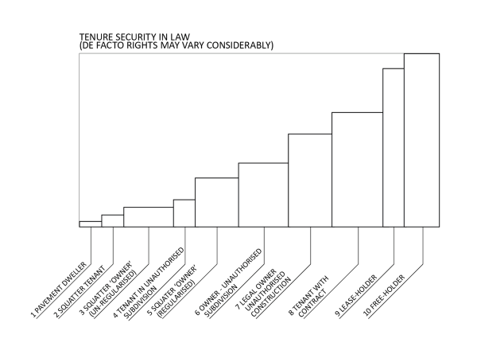
To prepare a full matrix, follow these simple steps:
- List the full range of tenure categories (formal. Semi-formal and non-formal, plus customary and religious categories) that you think exist in your city using the example above where appropriate but adapting it to reflect local conditions.
- If possible, indicate the proportion that each represents of the total housing stock. This can be achieved simply by adjusting the width of the tenure column to indicate a proportion of the total housing stock.
- Assess the level of de facto security associated with each tenure category. This may vary from the legal status since security is influenced by perception as well as legal status. List the categories according to their de facto level of tenure security, with low security on the left and categories with increasing tenure to the right.
- Indicate the level of rights associated with each tenure category within the following matrix. You can indicate easily if the rights apply to men only by inserting a backward slash (\), for women only a forward slash (/) and for men and women equally, a cross (x). For each category, it is useful to distinguish between the tenure holder and tenants. The matrix is shown below:

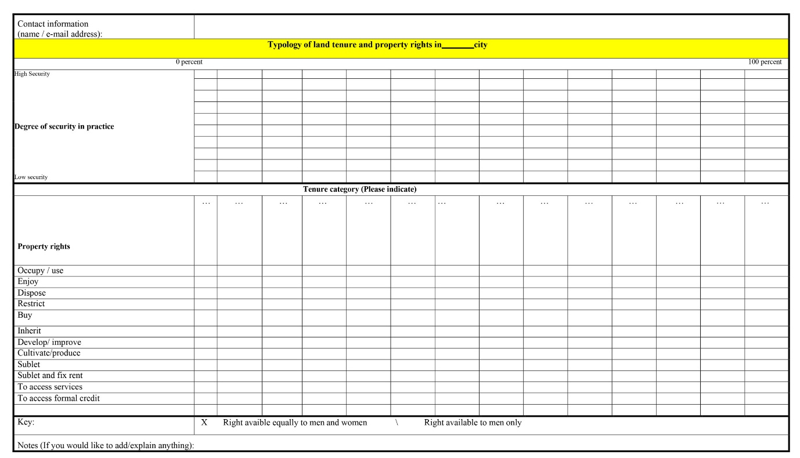
This exercise can be very helpful in developing policies. The recommended approach is to identify any significant gaps in the level of perceived tenure security as this will indicate a barrier to moving from one tenure category to another. By introducing new options to bridge the gap, new options will be provided to meet demand and enable people to find an option that meets their needs.
This approach is NOT intended to formalise all tenure options in the short term as policies that provide one option (eg individual titles) have been shown to be ineffective in meeting diverse needs. Experience shows that it is better to work with what exists and improve it, at least in the short to medium term. More formal options can then be developed in the medium to long term.
If you would like to complete one for your city and have it included in this list of examples, please send it to Geoff at gpalandmatrix@gmail.com – I hope it proves useful and fun!

